**Exercise 1: Control Structures**

**Scenario 1: The bank wants to apply a discount to loan interest rates for customers above 60 years old.**

**PL/SQL Query:**

BEGIN

FOR rec IN (SELECT * FROM Loans l JOIN Customers c ON l.CustomerID = c.CustomerID) LOOP

IF MONTHS_BETWEEN(SYSDATE, rec.DOB)/12 > 60 THEN

UPDATE Loans

SET InterestRate = InterestRate - 1

WHERE LoanID = rec.LoanID;

END IF;

END LOOP;

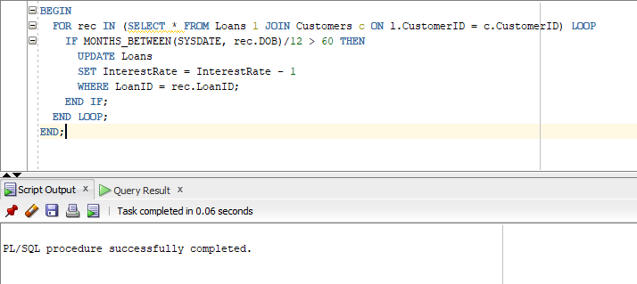END;

**Scenario 2: A customer can be promoted to VIP status based on their balance.**

**PL/SQL Query:**

ALTER TABLE Customers ADD IsVIP VARCHAR2(5);

BEGIN

FOR rec IN (SELECT * FROM Customers) LOOP

IF rec.Balance > 10000 THEN

UPDATE Customers SET IsVIP = 'TRUE' WHERE CustomerID = rec.CustomerID;

END IF;

END LOOP;

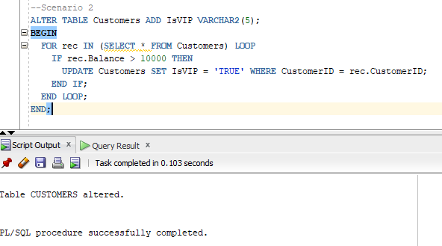END;

**Scenario 3: The bank wants to send reminders to customers whose loans are due within the next 30 days.**

**PL/SQL Query:**

BEGIN

FOR rec IN (

SELECT * FROM Loans WHERE EndDate BETWEEN SYSDATE AND SYSDATE + 30

) LOOP

DBMS_OUTPUT.PUT_LINE('Reminder: Loan ID ' || rec.LoanID || ' is due soon.');

END LOOP;

END;

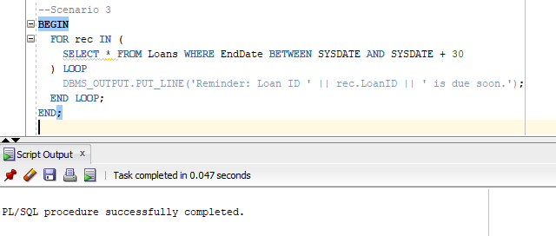

**Exercise 2: Error Handling**

**Scenario 1: Handle exceptions during fund transfers between accounts.**

**PL/SQL Query:**

CREATE PROCEDURE SafeTransferFunds(

p_from NUMBER,

p_to NUMBER,

p_amount NUMBER

) IS

v_balance NUMBER;

BEGIN

SELECT Balance INTO v_balance

FROM Accounts

WHERE AccountID = p_from

FOR UPDATE;

IF v_balance < p_amount THEN

RAISE_APPLICATION_ERROR(-20001, 'Insufficient funds in source account.');

END IF;

UPDATE Accounts

SET Balance = Balance - p_amount

WHERE AccountID = p_from;

UPDATE Accounts

SET Balance = Balance + p_amount

WHERE AccountID = p_to;

COMMIT;

EXCEPTION

WHEN NO_DATA_FOUND THEN

ROLLBACK;

DBMS_OUTPUT.PUT_LINE('One of the accounts does not exist.');

WHEN OTHERS THEN

ROLLBACK;

DBMS_OUTPUT.PUT_LINE('Error: ' || SQLERRM);

END;

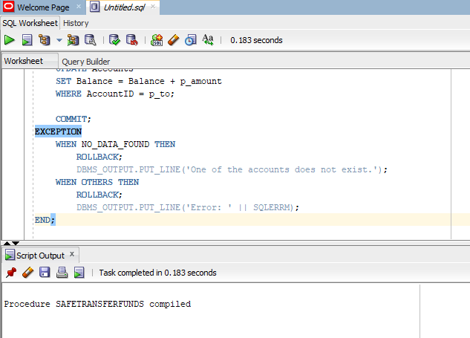

**Scenario 2: Manage errors when updating employee salaries.**

**PL/SQL Query:**

CREATE PROCEDURE UpdateSalary(p_empid NUMBER, p_percent NUMBER) IS

BEGIN

UPDATE Employees SET Salary = Salary + (Salary * p_percent / 100) WHERE EmployeeID = p_empid;

IF SQL%ROWCOUNT = 0 THEN

DBMS_OUTPUT.PUT_LINE('Error: Employee not found.');

END IF;

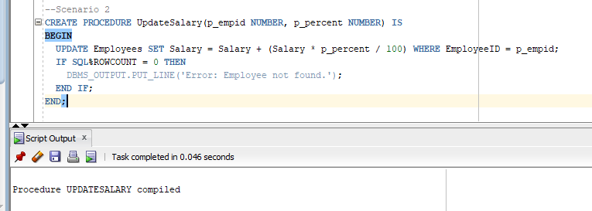END;

**Scenario 3:** Customers should be able to transfer funds between their accounts.

**PL/SQL Query:**

CREATE PROCEDURE AddNewCustomer(p_id NUMBER, p_name VARCHAR2, p_dob DATE, p_balance NUMBER) IS

BEGIN

INSERT INTO Customers(CustomerID, Name, DOB, Balance, LastModified)

VALUES (p_id, p_name, p_dob, p_balance, SYSDATE);

EXCEPTION

WHEN DUP_VAL_ON_INDEX THEN

DBMS_OUTPUT.PUT_LINE('Error: Customer with this ID already exists.');

END;

**Exercise 3: Stored Procedures**

**Scenario 1: The bank needs to process monthly interest for all savings accounts.**

**PL/SQL Query:**

CREATE PROCEDURE ProcessMonthlyInterest AS

BEGIN

UPDATE Accounts

SET Balance = Balance * 1.01,

LastModified = SYSDATE

WHERE AccountType = 'Savings';

COMMIT;

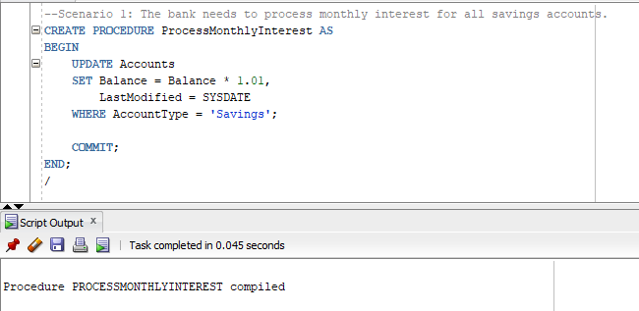END;

**Scenario 2: The bank wants to implement a bonus scheme for employees based on their performance.**

**PL/SQL Query:**

CREATE PROCEDURE UpdateEmployeeBonus (

p_department IN VARCHAR2,

p_bonus_percent IN NUMBER

) AS

BEGIN

UPDATE Employees

SET Salary = Salary + (Salary * p_bonus_percent / 100)

WHERE Department = p_department;

COMMIT;

END;

**Scenario 3: Customers should be able to transfer funds between their accounts.**

**PL/SQL Query:**

CREATE SEQUENCE TRANSACTIONS_SEQ START WITH 1001 INCREMENT BY 1;

CREATE PROCEDURE TransferFunds (

p_from_account IN NUMBER,

p_to_account IN NUMBER,

p_amount IN NUMBER

) AS

v_balance NUMBER;

BEGIN

SELECT Balance INTO v_balance

FROM Accounts

WHERE AccountID = p_from_account

FOR UPDATE;

IF v_balance < p_amount THEN

RAISE_APPLICATION_ERROR(-20001, 'Insufficient funds in source account');

END IF;

UPDATE Accounts

SET Balance = Balance - p_amount,

LastModified = SYSDATE

WHERE AccountID = p_from_account;

UPDATE Accounts

SET Balance = Balance + p_amount,

LastModified = SYSDATE

WHERE AccountID = p_to_account;

INSERT INTO Transactions (TransactionID, AccountID, TransactionDate, Amount, TransactionType)

VALUES (TRANSACTIONS_SEQ.NEXTVAL, p_from_account, SYSDATE, p_amount, 'Transfer Out');

INSERT INTO Transactions (TransactionID, AccountID, TransactionDate, Amount, TransactionType)

VALUES (TRANSACTIONS_SEQ.NEXTVAL, p_to_account, SYSDATE, p_amount, 'Transfer In');

COMMIT;

END;

/

**Exercise 4: Functions**

**Scenario 1: Calculate the age of customers for eligibility checks.**

**PL/SQL Query:**

CREATE FUNCTION CalculateAge(p_dob DATE) RETURN NUMBER IS

BEGIN

RETURN FLOOR(MONTHS_BETWEEN(SYSDATE, p_dob)/12);

END;

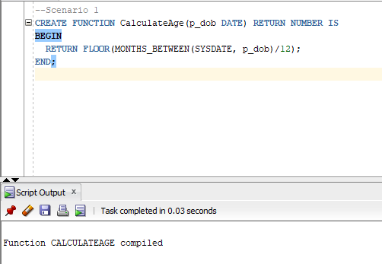

**Scenario 2: The bank needs to compute the monthly installment for a loan.**

**PL/SQL Query:**

CREATE FUNCTION CalculateMonthlyInstallment(

p_amount NUMBER,

p_rate NUMBER,

p_years NUMBER

) RETURN NUMBER IS

r NUMBER := p_rate / (12 * 100);

n NUMBER := p_years * 12;

BEGIN

RETURN (p_amount * r * POWER(1 + r, n)) / (POWER(1 + r, n) - 1);

END;

**Scenario 3: Check if a customer has sufficient balance before making a transaction.**

**PL/SQL Query:**

CREATE FUNCTION HasSufficientBalance(p_accountid NUMBER, p_amount NUMBER) RETURN BOOLEAN IS

bal NUMBER;

BEGIN

SELECT Balance INTO bal FROM Accounts WHERE AccountID = p_accountid;

RETURN bal >= p_amount;

EXCEPTION

WHEN NO_DATA_FOUND THEN

RETURN FALSE;

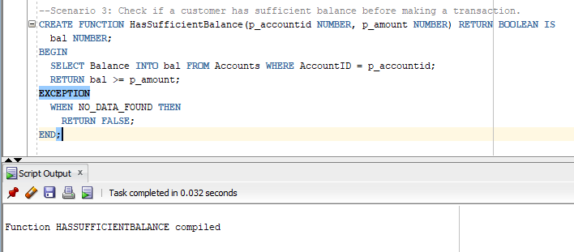END;

**Exercise 5: Triggers**

**Scenario 1: Automatically update the last modified date when a customer's record is updated.**

**PL/SQL Query:**

CREATE TRIGGER UpdateCustomerLastModified

BEFORE UPDATE ON Customers

FOR EACH ROW

BEGIN

:NEW.LastModified := SYSDATE;

END;

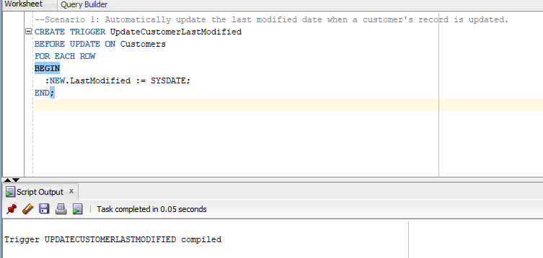

**Scenario 2: Maintain an audit log for all transactions.**

**PL/SQL Query:**

CREATE SEQUENCE AuditLog_SEQ

START WITH 1

INCREMENT BY 1

NOCACHE

NOCYCLE;

CREATE TABLE AuditLog (

LogID NUMBER PRIMARY KEY,

TransactionID NUMBER,

LogDate DATE,

Message VARCHAR2(100)

);

CREATE TRIGGER LogTransaction

AFTER INSERT ON Transactions

FOR EACH ROW

BEGIN

INSERT INTO AuditLog (

LogID,

TransactionID,

LogDate,

Message

) VALUES (

AuditLog_SEQ.NEXTVAL,

:NEW.TransactionID,

SYSDATE,

'Transaction successfully recorded in audit log.'

);

END;

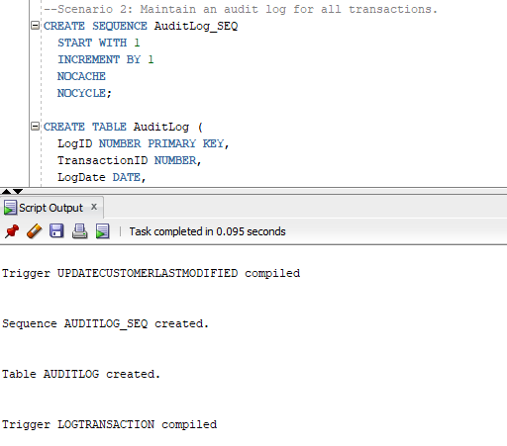

**Scenario 3: Enforce business rules on deposits and withdrawals.**

**PL/SQL Query:**

CREATE TRIGGER CheckTransactionRules

BEFORE INSERT ON Transactions

FOR EACH ROW

DECLARE

bal NUMBER;

BEGIN

SELECT Balance INTO bal FROM Accounts WHERE AccountID = :NEW.AccountID;

IF :NEW.TransactionType = 'Withdrawal' AND :NEW.Amount > bal THEN

RAISE_APPLICATION_ERROR(-20001, 'Insufficient balance');

ELSIF :NEW.TransactionType = 'Deposit' AND :NEW.Amount <= 0 THEN

RAISE_APPLICATION_ERROR(-20002, 'Deposit must be positive');

END IF;

END;

**Exercise 6: Cursors**

**Scenario 1: Generate monthly statements for all customers.**

**PL/SQL Query:**

DECLARE

CURSOR cur IS

SELECT c.Name, t.Amount, t.TransactionType

FROM Customers c

JOIN Accounts a ON c.CustomerID = a.CustomerID

JOIN Transactions t ON a.AccountID = t.AccountID

WHERE TRUNC(t.TransactionDate, 'MM') = TRUNC(SYSDATE, 'MM');

BEGIN

FOR rec IN cur LOOP

DBMS_OUTPUT.PUT_LINE('Customer: ' || rec.Name || ', Type: ' || rec.TransactionType || ', Amount: ' || rec.Amount);

END LOOP;

END;

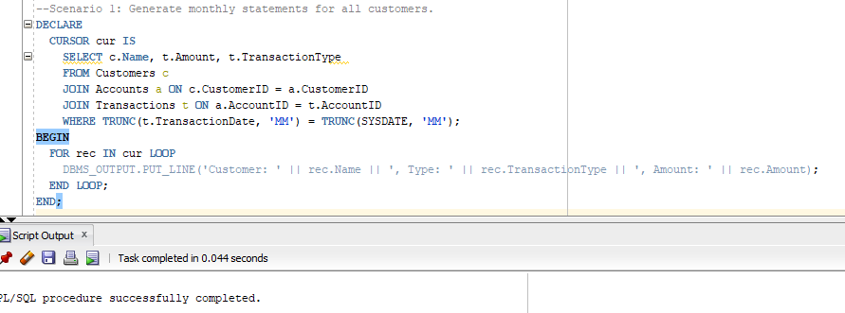

**Scenario 2: Apply annual fee to all accounts.**

**PL/SQL Query:**

DECLARE

CURSOR cur IS SELECT AccountID FROM Accounts;

BEGIN

FOR rec IN cur LOOP

UPDATE Accounts

SET Balance = Balance - 100

WHERE AccountID = rec.AccountID;

END LOOP;

END;

**Scenario 3: Update the interest rate for all loans based on a new policy.**

**PL/SQL Query:**

DECLARE

CURSOR cur IS SELECT LoanID, InterestRate FROM Loans;

BEGIN

FOR rec IN cur LOOP

UPDATE Loans

SET InterestRate = rec.InterestRate + 0.5

WHERE LoanID = rec.LoanID;

END LOOP;

END;

**Exercise 7: Packages**

**Scenario 1: Group all customer-related procedures and functions into a package.**

**PL/SQL Query:**

CREATE OR REPLACE PACKAGE CustomerManagement AS

PROCEDURE AddCustomer(p_id NUMBER, p_name VARCHAR2, p_dob DATE, p_balance NUMBER);

PROCEDURE UpdateCustomer(p_id NUMBER, p_balance NUMBER);

FUNCTION GetBalance(p_id NUMBER) RETURN NUMBER;

END CustomerManagement;

/

-- Create the package body

CREATE OR REPLACE PACKAGE BODY CustomerManagement AS

PROCEDURE AddCustomer(p_id NUMBER, p_name VARCHAR2, p_dob DATE, p_balance NUMBER) IS

BEGIN

INSERT INTO Customers (CustomerID, Name, DOB, Balance, LastModified)

VALUES (p_id, p_name, p_dob, p_balance, SYSDATE);

END;

PROCEDURE UpdateCustomer(p_id NUMBER, p_balance NUMBER) IS

BEGIN

UPDATE Customers

SET Balance = p_balance, LastModified = SYSDATE

WHERE CustomerID = p_id;

END;

FUNCTION GetBalance(p_id NUMBER) RETURN NUMBER IS

v_balance NUMBER;

BEGIN

SELECT Balance INTO v_balance

FROM Customers

WHERE CustomerID = p_id;

RETURN v_balance;

END;

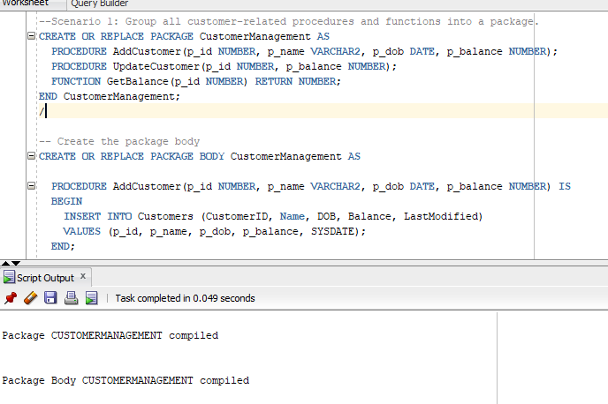END CustomerManagement;  
/

**Scenario 2: Group all customer-related procedures and functions into a package.**

**PL/SQL Query:**

CREATE OR REPLACE PACKAGE EmployeeManagement AS

PROCEDURE HireEmployee(

p_EmpID IN NUMBER,

p_Name IN VARCHAR2,

p_Position IN VARCHAR2,

p_Salary IN NUMBER,

p_Department IN VARCHAR2,

p_HireDate IN DATE

);

PROCEDURE UpdateEmployee(

p_EmpID IN NUMBER,

p_Name IN VARCHAR2,

p_Position IN VARCHAR2,

p_Salary IN NUMBER,

p_Department IN VARCHAR2

);

FUNCTION GetAnnualSalary(

p_EmpID IN NUMBER

) RETURN NUMBER;

END EmployeeManagement;

/

CREATE OR REPLACE PACKAGE BODY EmployeeManagement AS

PROCEDURE HireEmployee(

p_EmpID IN NUMBER,

p_Name IN VARCHAR2,

p_Position IN VARCHAR2,

p_Salary IN NUMBER,

p_Department IN VARCHAR2,

p_HireDate IN DATE

) IS

BEGIN

INSERT INTO Employees (EmployeeID, Name, Position, Salary, Department, HireDate)

VALUES (p_EmpID, p_Name, p_Position, p_Salary, p_Department, p_HireDate);

END HireEmployee;

PROCEDURE UpdateEmployee(

p_EmpID IN NUMBER,

p_Name IN VARCHAR2,

p_Position IN VARCHAR2,

p_Salary IN NUMBER,

p_Department IN VARCHAR2

) IS

BEGIN

UPDATE Employees

SET Name = p_Name,

Position = p_Position,

Salary = p_Salary,

Department = p_Department

WHERE EmployeeID = p_EmpID;

END UpdateEmployee;

FUNCTION GetAnnualSalary(

p_EmpID IN NUMBER

) RETURN NUMBER IS

v_Salary NUMBER;

BEGIN

SELECT Salary INTO v_Salary

FROM Employees

WHERE EmployeeID = p_EmpID;

RETURN v_Salary * 12;

END GetAnnualSalary;

END EmployeeManagement;

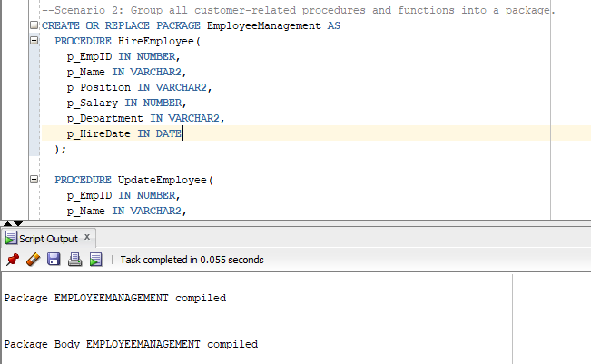/

**Scenario 3: Group all customer-related procedures and functions into a package.**

**PL/SQL Query:**

CREATE OR REPLACE PACKAGE AccountOperations AS

PROCEDURE OpenAccount(

p_AccountID IN NUMBER,

p_CustomerID IN NUMBER,

p_AccountType IN VARCHAR2,

p_InitialBalance IN NUMBER

);

PROCEDURE CloseAccount(

p_AccountID IN NUMBER

);

FUNCTION GetTotalBalance(

p_CustomerID IN NUMBER

) RETURN NUMBER;

END AccountOperations;

/

CREATE OR REPLACE PACKAGE BODY AccountOperations AS

PROCEDURE OpenAccount(

p_AccountID IN NUMBER,

p_CustomerID IN NUMBER,

p_AccountType IN VARCHAR2,

p_InitialBalance IN NUMBER

) IS

BEGIN

INSERT INTO Accounts (AccountID, CustomerID, AccountType, Balance, LastModified)

VALUES (p_AccountID, p_CustomerID, p_AccountType, p_InitialBalance, SYSDATE);

END OpenAccount;

PROCEDURE CloseAccount(

p_AccountID IN NUMBER

) IS

BEGIN

DELETE FROM Accounts

WHERE AccountID = p_AccountID;

END CloseAccount;

FUNCTION GetTotalBalance(

p_CustomerID IN NUMBER

) RETURN NUMBER IS

v_TotalBalance NUMBER;

BEGIN

SELECT NVL(SUM(Balance), 0)

INTO v_TotalBalance

FROM Accounts

WHERE CustomerID = p_CustomerID;

RETURN v_TotalBalance;

END GetTotalBalance;

END AccountOperations;

/

